CS 228: ASSIGNMENT 1
Report and Analysis

Kunal Elchipuram
018521360

Introduction:
We implemented a gait-based user identification system (10-class classification) using a Feed-Forward Neural Network on engineered features extracted from 6-channel inertial signals (accelerometer and gyroscope) after which we use an LSTM network to do the sam.. The pipeline follows the assignment’s requirements for preprocessing, feature engineering, feature selection, model design, and cross-validation. The tasks performed are user identification and user verification for the data.
DataPreprocessing:
Data Preprocessing began by first understanding the type of data that was present. The dataset consists of time-series sensor readings from mobile phones, specifically accelerometer data capturing linear acceleration and gyroscope data measuring angular velocity, both recorded across three axes (X, Y, Z) for 10 distinct users during gait activities.
As mentioned in the assignment , I first combined data from both the accelerometer and gyroscope into a single 6 channeled csv file, with matching timestamps. Following which I windowed the data following the assignment instructions of 500 window size and 50% overlap.
Following that , to clean the data , I proceeded with Z-score clipping and then followed it up with moving average smoothing. I chose z score clipping where (z>3) as sensor data is often noisy and may contain outliers in the data due to jitters or vibrations or random measurement errors. I also applied moving average smoothing with a smoothing window of 5 as it reduces high-frequency noise without distorting the underlying gait patterns, ensuring cleaner inputs for both FNN and LSTM models.

FNN Approach:
For the Feed forward Neural network approach i selected 16 features from each of the 6 channels namely - mean, std, var, median, iqr, min_val, max_val, range_val,energy, rms, zero_crossings, mad, skewness, kurt, dominant_freq_idx, spectral_energy. These were computed using libraries like NumPy and SciPy, aligning with the assignment's requirement for at least 20 diverse features to capture gait characteristics.
And for Feature selection- to reduce it to 10 features , I used SelectKBest (ANOVA F-value) to choose the top 10 features most predictive of user identity. This method is simple, fast, and well-matched to linear separability tests before a non-linear classifier. This technique was chosen because it evaluates feature relevance based on statistical significance for classification, aligning well with the multi-class identification task and providing a clear, interpretable ranking of features.
For the Feedforward Neural Network (FNN) and the LSTM Model, StandardScaler was applied to the selected 10 features, standardizing them to have zero mean and unit variance, which stabilizes training by handling varying feature scales and improving convergence.
I then proceeded to create a simple FNN with two hidden layers of 5 neurons each . ReLU activations, and a softmax output
For training- Stratified K-Fold cross-validation with K=5 folds was used, ensuring balanced class representation in each fold. Also provided reliable averages for metrics like accuracy, F1-score, FAR, FRR, EER, and AUC in both identification and verification tasks.
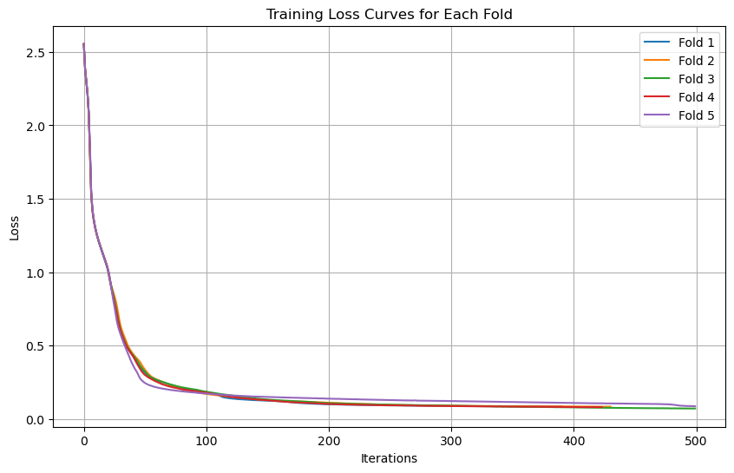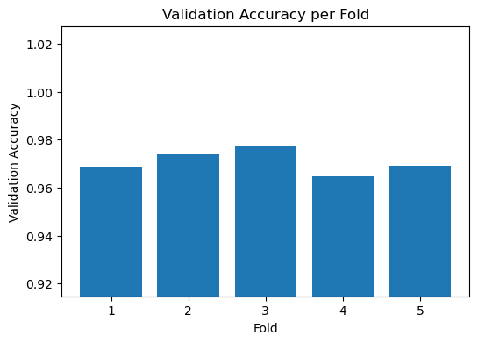

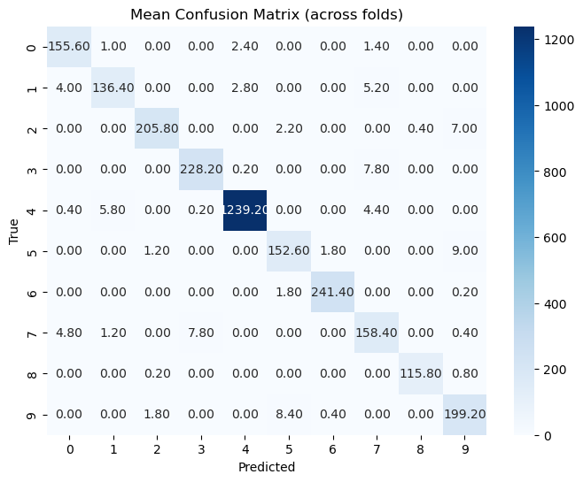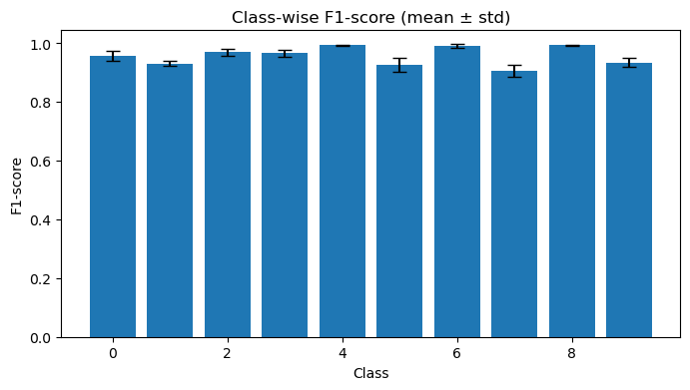
From left to right and top to bottom Fig1- training loss across 5 folds. Fig2 val acc across 5 folds. Fig 3 confusion matrix. Fig 5 f1 score across each of the 10 classes.

LSTM Approach:
For the LSTM Network, I reused the same cleaned windowed data. Again followed Standard scaling and Kfold cross validation where K =5. Following the constraints of the assignment, I used only 3 hidden layers along with dropouts, with each layer having equal to or lesser than 6 neurons.
For evaluation metrics calculated : precision, recall, f1 score, auc and roc ( although not plotted due to lack of space).
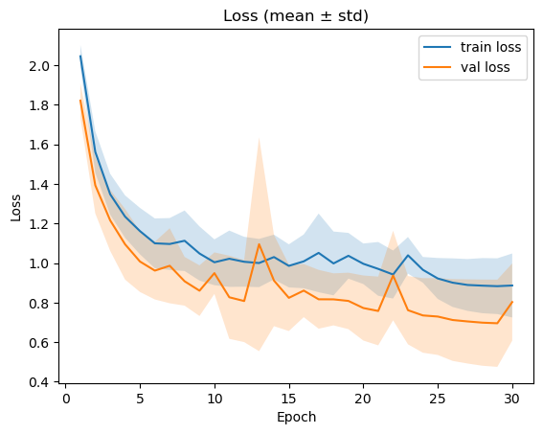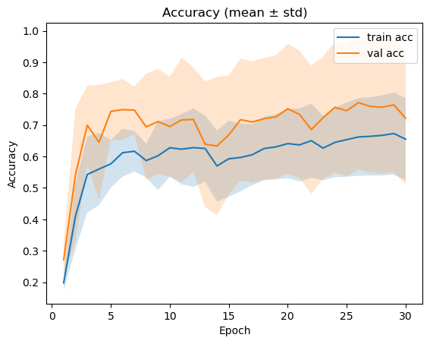

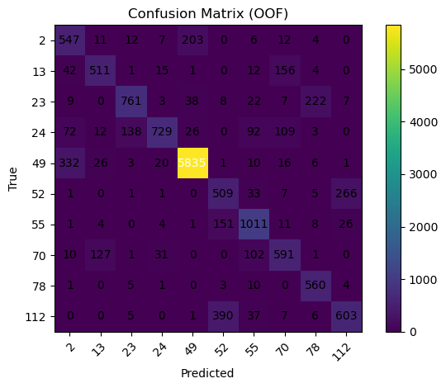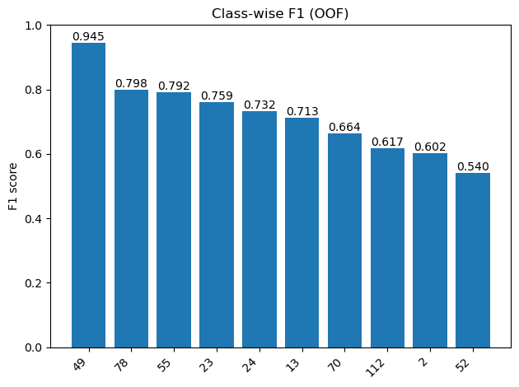
From left to right and top to bottom Fig1: training loss. Fig2: training accuracy. Fig3: Confusion matrix. Fig4: Class wise f1 score.

User Verification
For Feed forward Neural Network: From the 10 features selected in the Identification task, I used 10 user specific models in a one vs all ( genuine vs imposter) method. The graphs for the AUC and the EER is given below
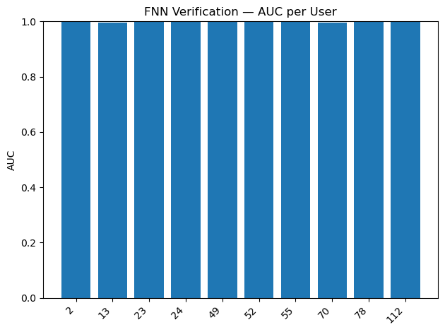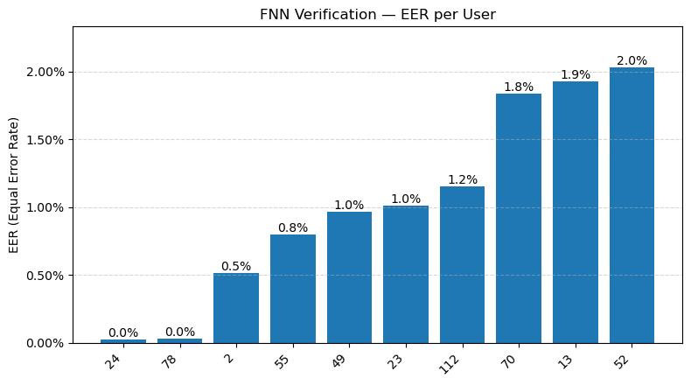

For LSTM: Since training data was taking over 3 hours - I had to reduce the training to 3 folds and for 5 users only. Below is the graphs for AUC per user and EER per user. Graphs for FAR@EER and FRR@EER is present in the notebook.
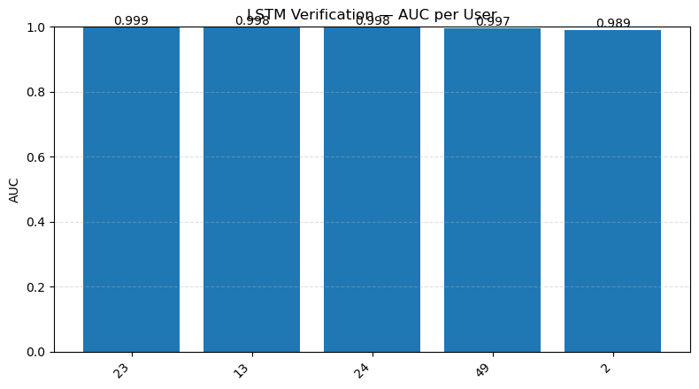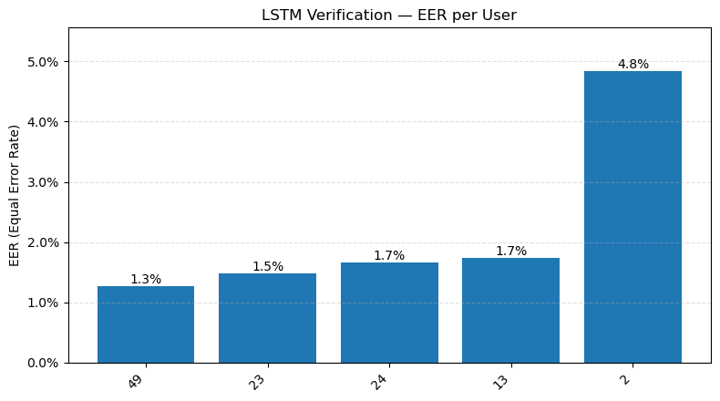

Learnings and Difficulties:
The following are the difficulties I faced during the assignment:
- Long training time: Training the LSTM-based models took significantly longer than expected, especially with large sequence inputs and multiple folds of cross-validation. Each model had to be trained separately for each user, which multiplied the computation time. Reducing epochs and folds later helped me manage this but came at the cost of slightly lower accuracy.

- Simplicity of LSTM model without additional adjustments ex dropout layer: The assignment constrained model size (maximum 5 layers, 6 units each), which limited experimentation with more expressive architectures. Without additional tuning or advanced regularization techniques (like recurrent dropout or batch normalization), the model risked underfitting or showing unstable validation behavior across folds.

